Results
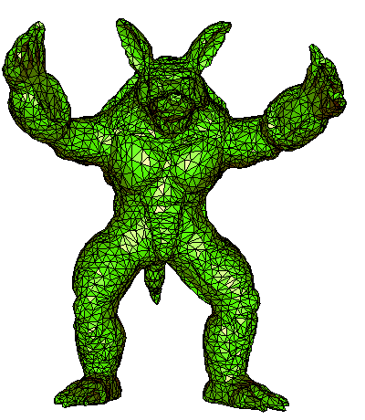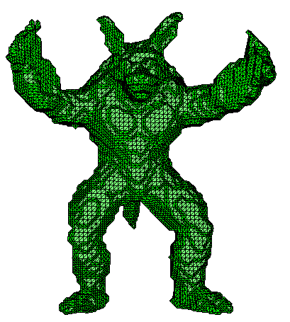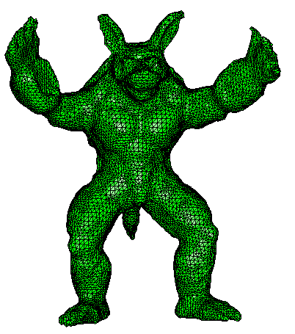
(a) Original mesh (b) Non-obtuse remeshing (c) Deform to fit result
Figure 1: first results.

Table 1: Angles statistics
 | (a) | (b) | (c)
Minimum angle | 5.0019 | 33.5562 | 15.6358
Maximum angle | 169.6228 | 90.0080 | 90.0071
Conclusion:
The sharp features are lost after the remeshing, such as the disappeared small valley in the red region in Figure 2. So in the future, we should improve the approximation error between the result and the original mesh.
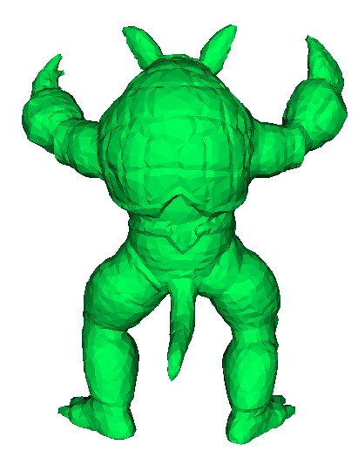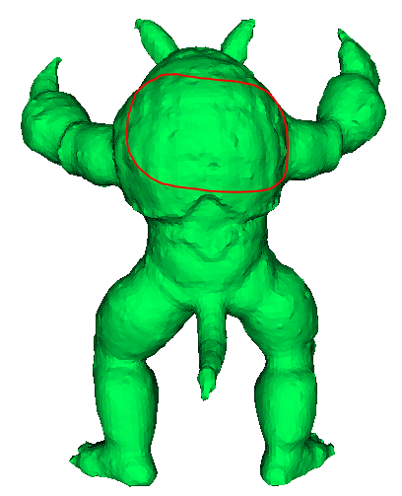
Original mesh Deform to fit
Figure 2: Comparison.

